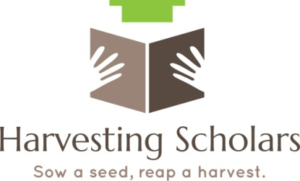
Scholar Participant Profile Form

Students Name: ____________________________________________________________________
Cell Phone: __________________________ Other Number:_________________________________
Address: __________________________________________________________________________
___________________________________________________________________________
Email Address: _____________________________________________________________________
Social Media Contact: Twitter: ____________________________Instagram: ___________________
Parents Name and Contact information (If student under age18)
Parents Name_______________________________________________
Parents Email_______________________________________________
Parents Phone_______________________________________________
Current School Student is Enrolled:________________________________________________________
County___________________________ School Phone_______________________________________
Guidance Counselors Name______________________________________________________________
Expected High School Graduation or GED Completion Date: ____________________________________
Do you know what you want to do when you graduate (i.e. nursing, Chef, musician)? Yes____ No____
Teacher | Mechanic | Journalist | Event Planner | Retail Manager | Psychologist | Forensic science
Musician | Lawyer | Film maker | Hotel manager | Business Analyst | Clergy | Criminal Justice
Doctor | Nurse | Architect | Nutritionist | Engineer | Political Analyst | Other
Veterinarian | Computer Technician | Business owner | Chef | Physical Therapist | Human recourse agent | Unsure

If Yes, What career are you considering?____________________________________________________
Are you planning to attend College/Tech school? Yes____ No_____ If Yes, What School(s) are you interested in?
1____________________________________________________________________________________
2____________________________________________________________________________________
3____________________________________________________________________________________
Have you ever taken the ACT? Yes_____ No____? If yes, what were your scores?________________
Have you ever taken the SAT? Yes_____No_____? If yes, what were your scores?________________
If you are not planning to attend college, but plan to work immediately after graduation, have you considered where you want to work? Yes________ No__________?
Have you started applying for jobs? Yes_________ No___________?
If No, Do you know where you want to work?
_______________________________________________________________________________________________________________________________________________________________________________________________________________________________________________________________
What do you expect from Harvesting Scholars?
____________________________________________________________________________________________________________________________________________________________________________________________________________________________________________________________________________________________________________________________________________________
How did you hear about this organization?
_______________________________________________________________________________________________________________________________________________________________________________________________________________________________________________________________

What makes you unique, that sets you apart from anyone else?
_____________________________________________________________________________________________________________________________________________________________________________________________________________________________________________________________________________________________________________________________________________

Thank You

