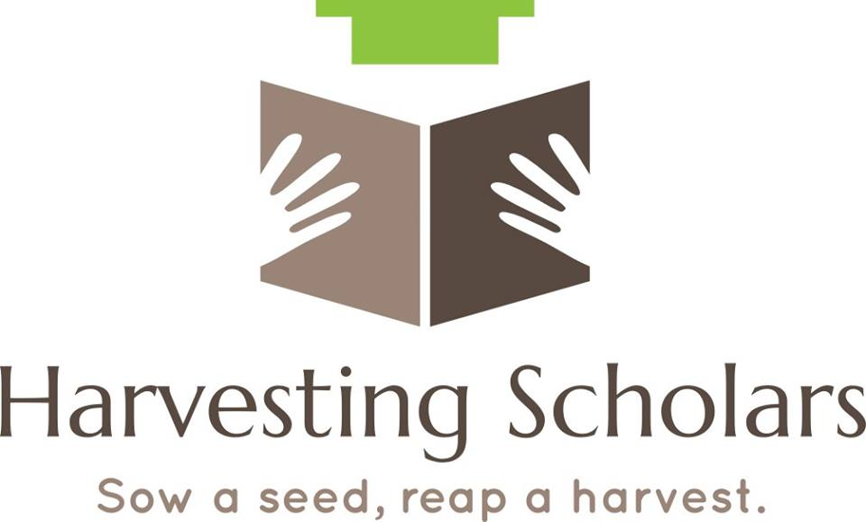

Scholarship Application
Note: Please read the content of this application carefully and answer each question completely before submitting.
The application packet must be submitted by:
July 31, 2019
Name: ________________________________________________________________________
Address: ______________________________________________________________________
City: _______________________________________ State: _____________ Zip: ____________
Phone: __________________________ Email: _______________________________________
High School You Attended: _______________________________________________________
City/State/Zip: _________________________________________________________________
Graduation date: _______________________________________________________________
Cumulative GPA: ________________ SAT Score: ______________ ACT Score: ______________
Have you been accepted at a College, University or Technical School? Yes ☐ No ☐
What college will you be attending this fall?__________________________________________
What is your major?______________________________________________________________
List any community service projects or school activities you have been involved in. (You may attach on a separate sheet)._____________________________________________________________
_______________________________________________________________________________
Essay: Please submit a typed 300-500 word essay answering the following:
Essay must be Double-spaced, Times New Roman Font, 12 pt
What are your educational and career goals and WHY should you be awarded this scholarship?

Recommendation Letters/References:
Please attach at minimum one (1) letter of recommendation/reference from one of the following: Teacher, guidance counselor or principal, pastor, or person in church leadership, or community leader. A relative may not provide a letter of reference for you.

Your Printed Name: ___________________________________________________________________
Your Signature: ___________________________________________ Date______________________

SCHOLARSHIP CHECKLIST
The scholarship applicant must:
- Applicant must be a graduate from a Georgia high school in Bartow, Floyd, Polk or Gordon County.
- Be enrolled in a college or university and have a minimum cumulative grade point average (GPA) of 2.5 or better
- Provide a copy of your current transcript
- Provide written proof of active school enrollment (class schedule, enrollment letter, etc.)
- Provide current, written evidence of participation in community service projects and/or school activities within the past year.
- Provide at minimum one (1) letter of recommendation/reference from one of the following: Teacher, guidance counselor or principal, pastor, or person in church leadership, or community leader. A relative may not provide a letter of reference for you.
- Type and submit a 300 to 500 word essay answering the following prompt:

What are your educational and career goals and WHY should you be awarded this scholarship?

- Submit completed packet no later than midnight July 31, 2019

Submit scholarship application packet to:
Harvesting Scholars
P.O. Box 4205
Cartersville, GA 30120
Or
Email completed packet to:
info@harvestingscholars.org

Scholarship award is $250
The decision of the Harvesting Scholars scholarship committee is final

